SMDM Project - Cold Storage Problem

Submitted by
Renjith Mohan K
02/02/2020

1Table of Contents
1 Project Objective..........................................................................................................…...........3
2 Assumptions...............................................................................................................................3
3 Exploratory Data Analysis – Step by step approach ..................................................................3
3.1 Environment Set up and Data Import...............................................................................…....3
3.1.1 Install necessary Packages and Invoke Libraries...............................................….….............3
3.1.2 Set up working Directory ...................................................................................……........…..3
3.1.3 Import and Read the Dataset...............................................................................……...........4
3.2 Variable Identification........................................................................................................…...4
3.2.1 Variable Identification – Inferences...........................................................................………...4
3.3 Univariate Analysis.............................................................................................................…...5
3.4 Bi-Variate Analysis...............................................................................................................…..8
3.5 Missing Value Identification................................................................................................…..11
3.6 Outlier Identification...........................................................................................................…..11
3.7 Variable Transformation / Feature Creation .....................................................................…...12
4 Assignment Questions & Solutions...............................................................................................................................…......12
4.1 Problem 1 Solution..................................................................................................................12
4.2 Problem 2 Solution............................................................................................................…...13
5 Conclusion..................................................................................................................................13
6 Appendix A – Source Code................................................................................................….......15

1 Project Objective
The objective of the report is to explore the Cold Storage data sets (Cold_Storage_Temp_Data.csv, Cold_Storage_Mar2018.csv) in R, generate insights about the data set and answer the relevant questions pertaining to both of these data sets. The report also aims in finding out the percentage fee that has to be paid to the AMC and also arriving at a conclusion regarding the root cause of recent problems that has happened at the plant.

This exploration report will consists of the following:
• Importing the dataset in R
• Understanding the structure of dataset
• Descriptive statistics
• Graphical exploration
•Insights from the dataset

2 Assumptions
- It is assumed that the problem statements - 1 & 2 are independent of each other and so we will be treating them separately.

- We assume that the data provided for Problem 1 & 2 are accurate and without any errors.

3 Exploratory Data Analysis – Step by step approach
A Typical Data exploration activity consists of the following steps:

1. Environment Set up and Data Import
2. Variable Identification
3. Univariate Analysis
4. Bi-Variate Analysis
5. Missing Value Treatment (Not in scope for our project)
6. Outlier Treatment (Not in scope for our project)
7. Variable Transformation / Feature Creation (Not in scope for our project)
8. Feature Exploration

We shall follow these steps in exploring the provided dataset.
Although Steps 5,6 and 7 are not in scope for this project, a brief about these steps (and other
steps as well) is given, as these are important steps for Data Exploration journey.

3.1 Environment Set up and Data Import
3.1.1 Install necessary Packages and Invoke Libraries
As apart of this problem(1 & 2), we installed the packages - “dplyr” and “ggplot2”. dplyr is a package that is used for data analysis purpose like aggregating, grouping etc and ggplot2 is used to create meaningful visualizations of feature variables.The packages were installed using install.packages() function and afterwards loaded into library with the aid of library() function.

Please refer Appendix A for Source Code

3.1.2 Set up working Directory
Setting a working directory on starting of the R session makes importing and exporting data
files and code files easier. Here the working directory is chosen as C:\2020\RProgramming\SMDM where
We have the data sets, codes etc. related to the project. We do this with the aid of setwd() function.

Please refer Appendix A for Source Code

3.1.3 Import and Read the Dataset
The given dataset is in .csv format. Hence, the command “read.csv” is used for importing the
file.

Please refer Appendix A for Source Code.

3.2 Variable Identification
For Variable identification, we use the R functions - dim, names, str, summary, head, tail. The purpose of each of the functions are briefly mentioned below -

dim - we use this to get the dimension of the data frame meaning the number of rows and columns.
names - we use this to identify the colum/variable names.
str - we use this to get the structure of the variable/column names like factor, integer or numeric.
summary - we use this to get a summary of the column names. It gives us the 5 point summary with details of min, max. Median, 25th percentile & 75th percentile.Basically we perform descriptive statistic with this one.
head - we use this to check a sample of data from the data frame. By default it gives the first 6 records.
tail - we use this also to check sample records from the data frame. By default it gives the last 6 records.

Please refer Appendix A for Source Code.

3.2.1 Variable Identification – Inferences
Below are the inferences from the variable identification step above :

The Cold Storage data set for 2016 has 365 rows and 4 columns which means that we have records throughout the year for 2016. The March 2018 Cold storage data has only 35 rows and 4 columns which means its a sample data taken for analysis. This make intuitive sense as we are only collecting a sample for the second data set.

Both Cold storage data sets ( 2016 & Mar-2018) have the same number of columns and names. These columns are 1) Season 2)Month 3)Date 4) Temperature. So our further analysis will be on these columns only.

For 2016 data set, the column- Season is a “Factor” variable with 3 levels, Month is also a “Factor” variable with 12 levels where as Date variable is an “integer” and Temperature is a “number” variable.
For 2018 data set, the column- Season is a “Factor” variable with 1 level, Month is also a “Factor” variable with 2 levels where as Date variable is an “integer” and Temperature is a “number” variable. So we have a mix of factor and integer/numeric variables from the data sets.It was observed that we have one continous variable (Temperature) and 3 categorical variables (Season, Month, Date). Even though Date is numeric, we can’t derive any insights by applying statistical methods on that field and so it would be omitted for further analysis.

The summary of 2016 data set reflects that we have 3 seasons in picture - 1) Rainy, 2) Summer & 3) Winter and the data is available for all the months of the year. The temperature for this data set is ranging from 1.7 to 5 with a mean & median of 2.9.
The summary of 2018 March data set reflects that we have only 1 season in picture - Summer.
This makes sense as we are collecting data only for 35 days time period. Also we have only 2 months data in picture for 2018 - Feb & Mar. The temperature for this data set is ranging from 3.8 to 4.6 with a mean & median of 3.9. One observation made here is that during 2018, there has been some effort from the management side to maintain the temperature within 3.9 range for the second data set as the mean value of 2018 data is much higher than the 2016 data.

Also another insight derived is that since the second data set is collected only during the Summer time period Vs different seasons of 2016, it might possibly bring in some seasonal bias to the second data set.

On checking sample records from both data sets, we confirmed that the records are properly arranged and labeled. We verified this by inspecting the first and last 6 rows of the data sets.

Please refer Appendix A for Source Code.

3.3 Univariate Analysis
We have taken the continuous variable for Univariate analysis which is “Temperature”. We can do this with the aid of a histogram in a ggplot(). The other variables in picture are Categorical variables and we do not get any insights by doing a univariate analysis for Date or Month. However we are taking into account the variable - “Season” to see the number of observations in each season.

Find below the pictorial representation for variable -”Temperature” for each of the data sets.

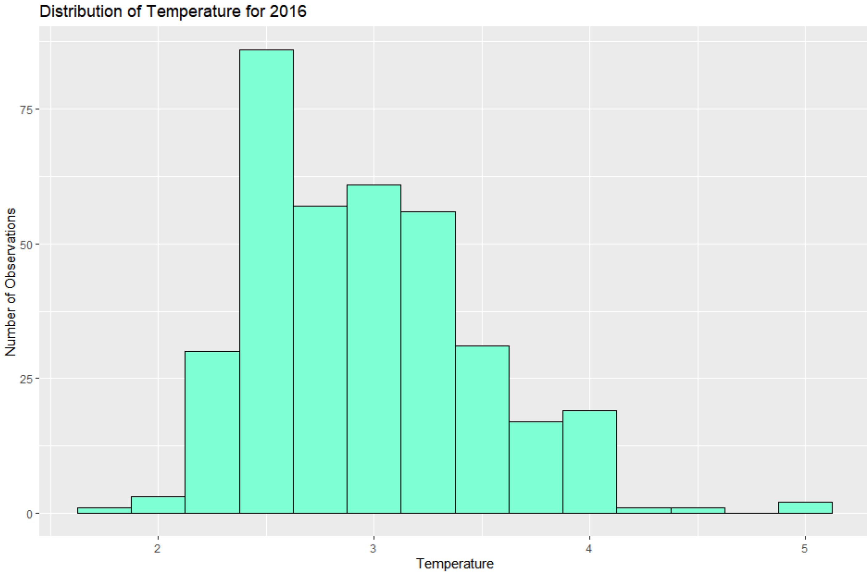

Observations: For 2016 data, the highest distribution of temperature is around 2.5 - 3. The temperatures of greater than 5 seem to be outlier
as there are only very few values in the distribution
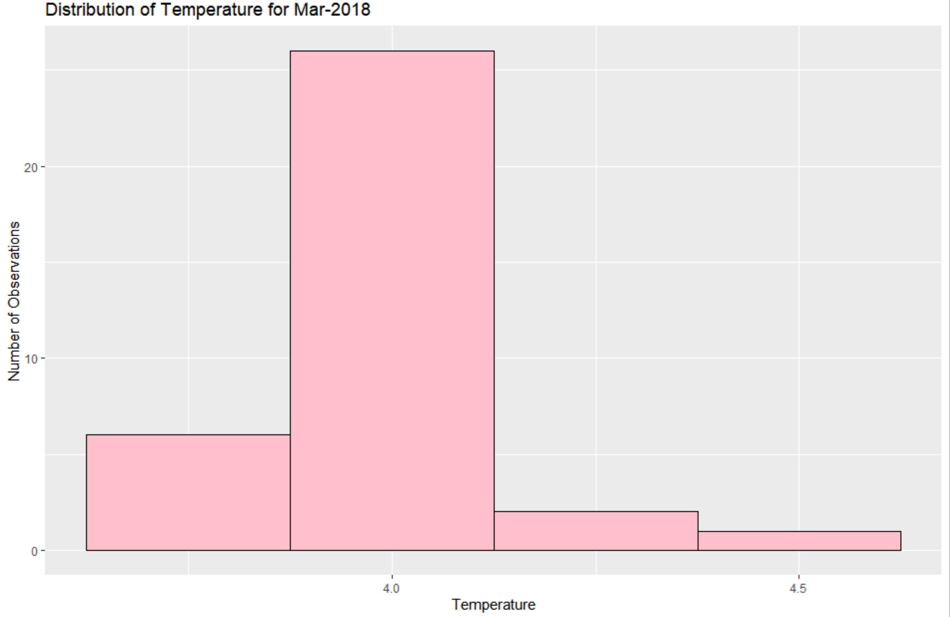
Observation: For 2018 March data, the highest distribution of temperature is around 4. The temperature of greater than 4.5 looks very unlikely from the distribution.

Find below the tabular format of temperature observations by each Season and a graphical plot depicting the same.

For 2016 data set:

Rainy Summer Winter
122 120 123

For 2018 data set:

Summer
35
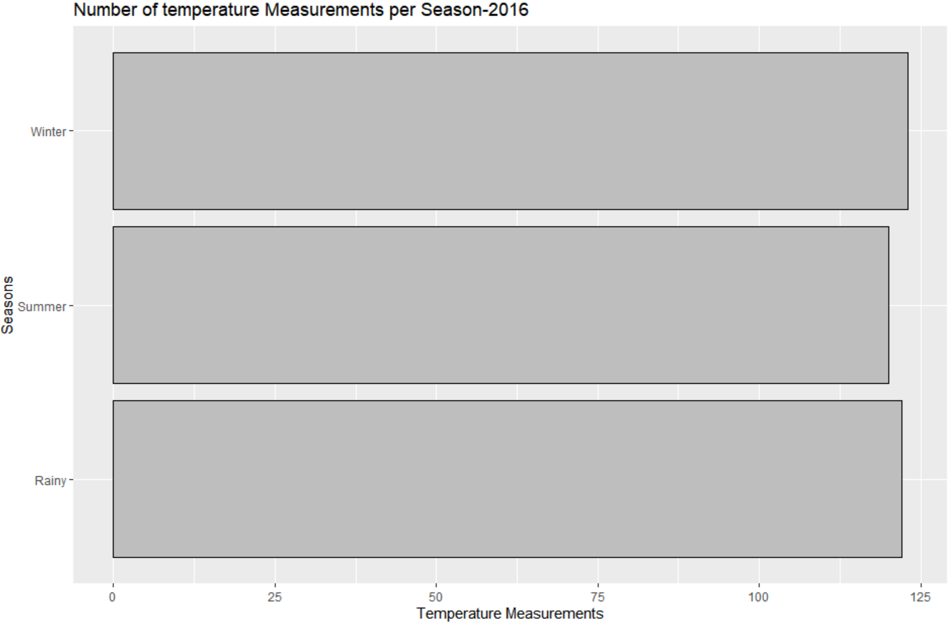
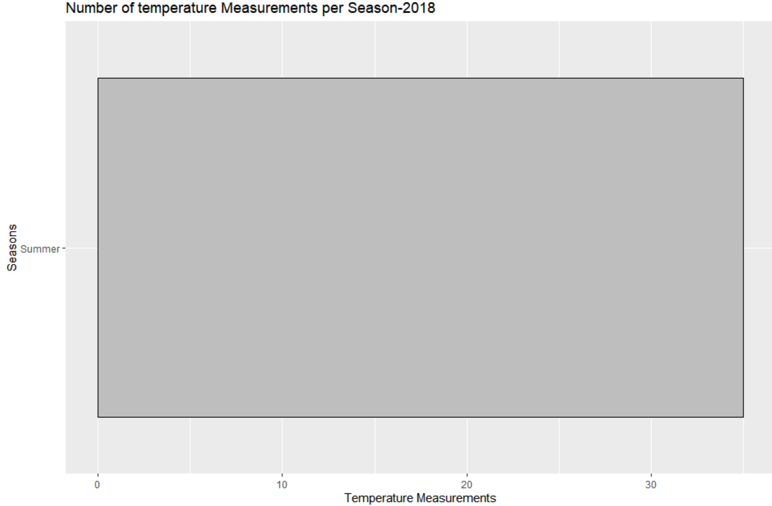

Observations: We can see that the total number of temperature observations are almost consistent across each seasons for 2016 and all observations pertain to only one season for 2018(Summer).

Please refer Appendix A for Source Code.

3.4 Bi-Variate Analysis
For Bivariate analysis, we will use the numerical variable -”Temperature” and plot it against the Categorical Variables - “Season” and “Month”. To make deductions, we will use a box plot. Finally we do a multi variate analysis graph by plotting temperature against Season and Month.

- Box plot of Temperature against Seasons:
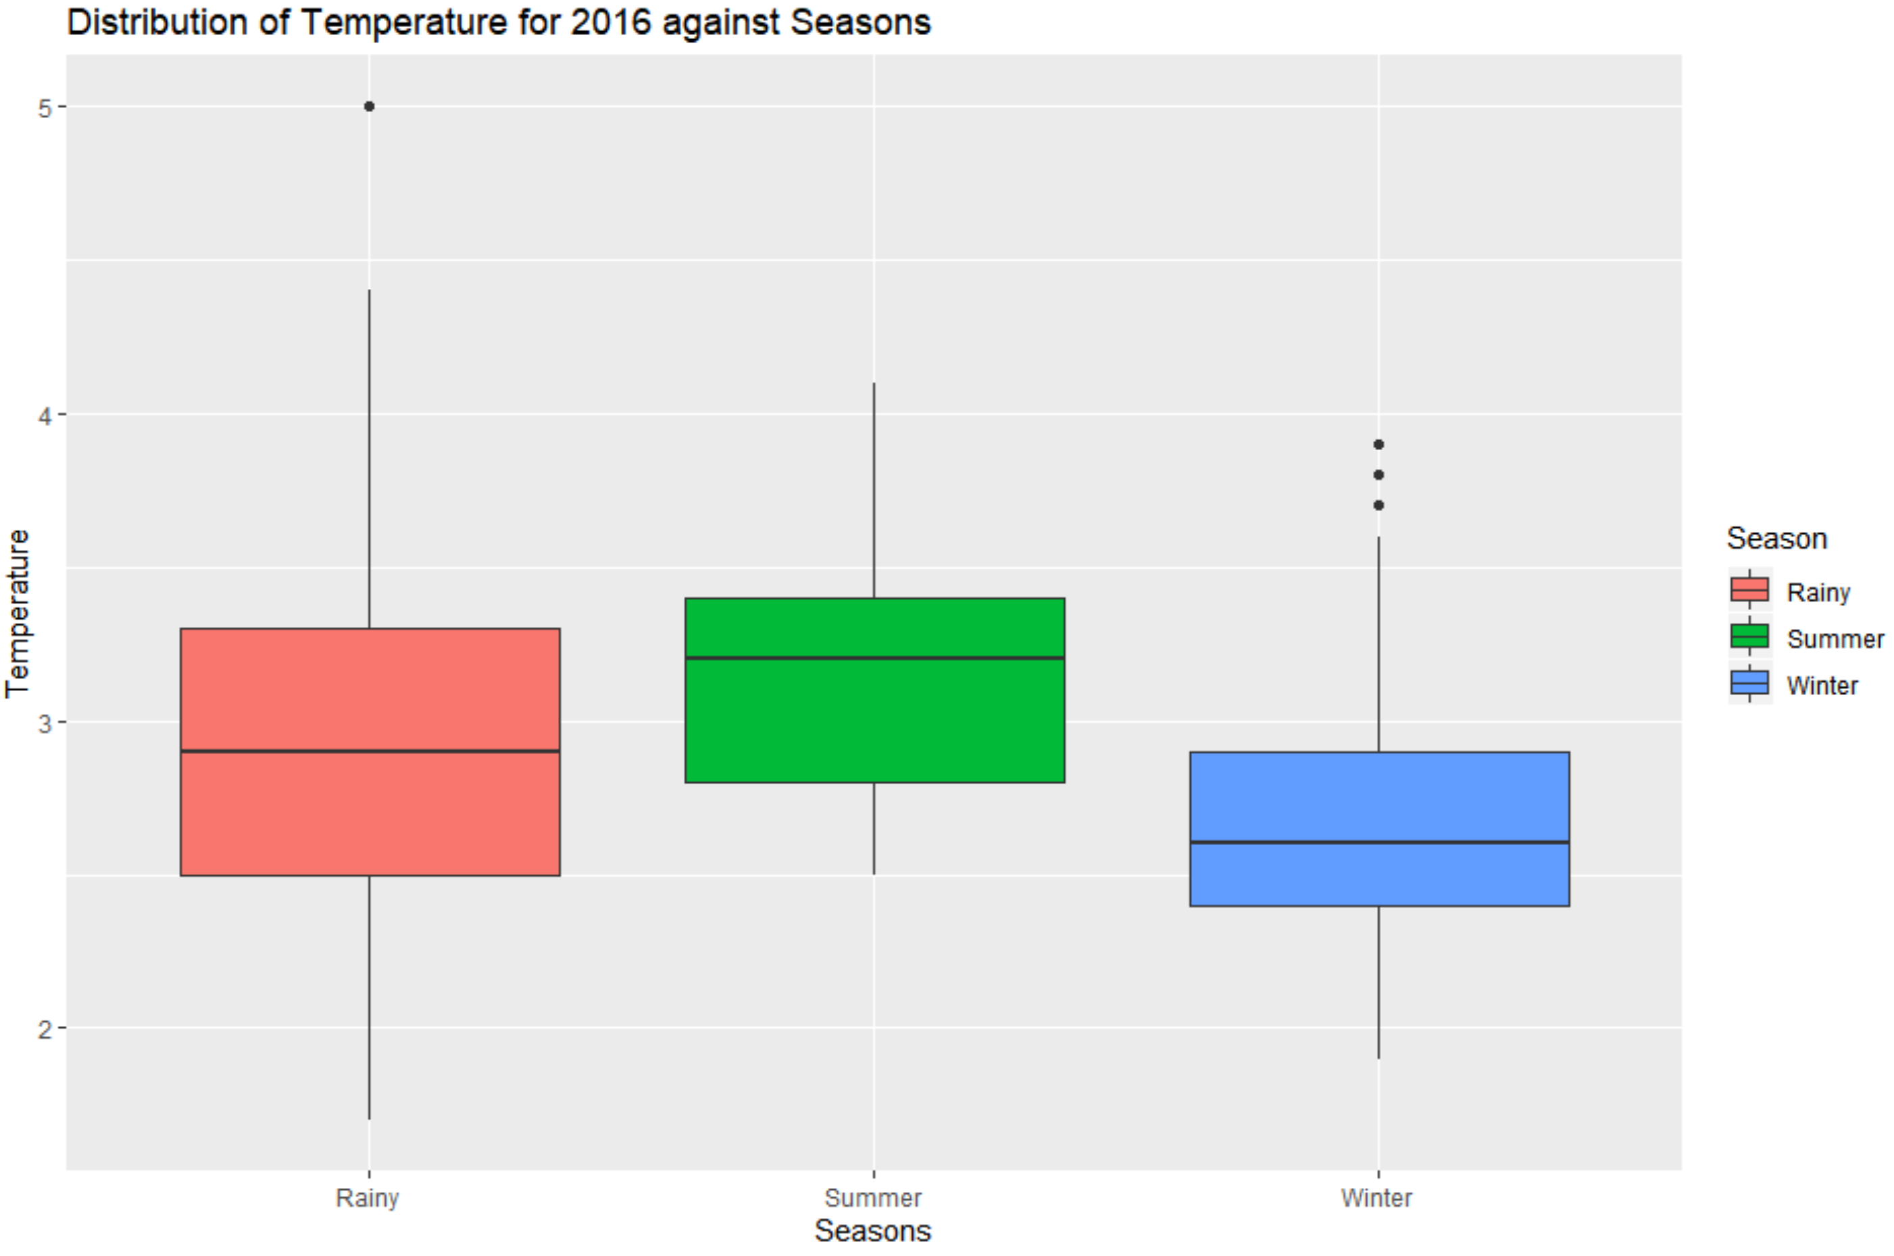
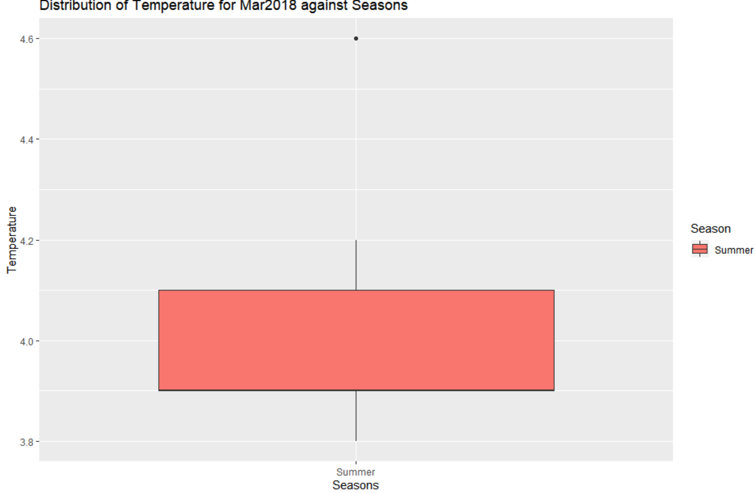

Observations: One of the observations from the first data set is that among all the seasons, the mean temperature is higher for Summer season followed by Rainy Season.Also the peak temperature is observed on a rainy season which is an outlier and we have other 3 outliers for Winter season and no ouliers for Summer season ( these are ouliers within the seasons and may not be there when we look at the whole data).We do not know yet these outliers belong to which month of the year.

For the second data set, we have an oulier value at 4.6 degrees, but do not know if it belong to Feb or March months.

- Box plot of Temperature against Months :

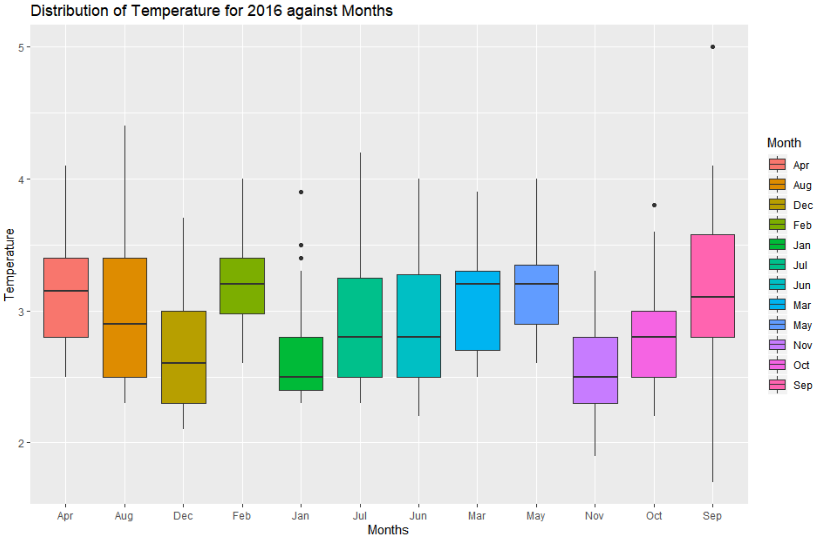
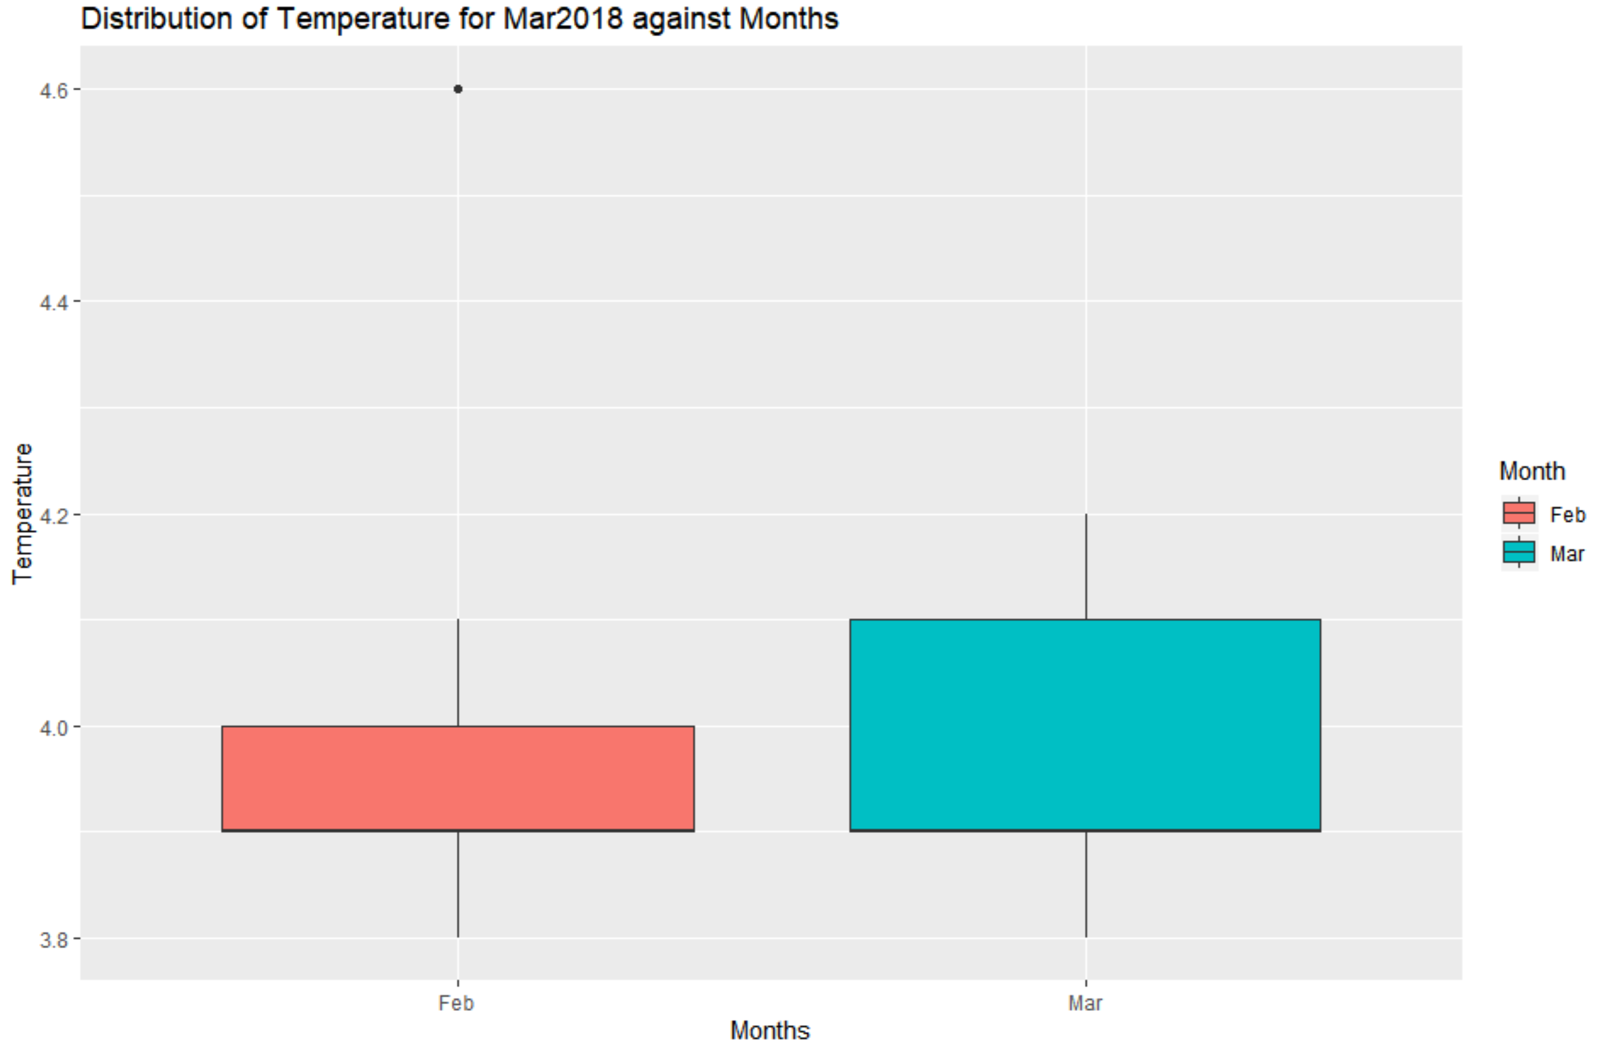

Observations: Looking at the boxplots for Temperature against Months, we see that in the first data set, the mean temperature is higher for Feb, Apr, Mar & May months and lower for Jan month. Also we figure out that most of the outliers are from Jan month(3) and we have one outlier each for Sep & Oct months. The most extreme temperatures were recorded for Sep month (Max & Minimum values).
For the second data set, we infer that there is only one outlier value that came from Feb month.

- Box plot of Month against Temperature. We are doing this plot only with the first data set since the second data set have only one season and don’t give much insights plotting against it.

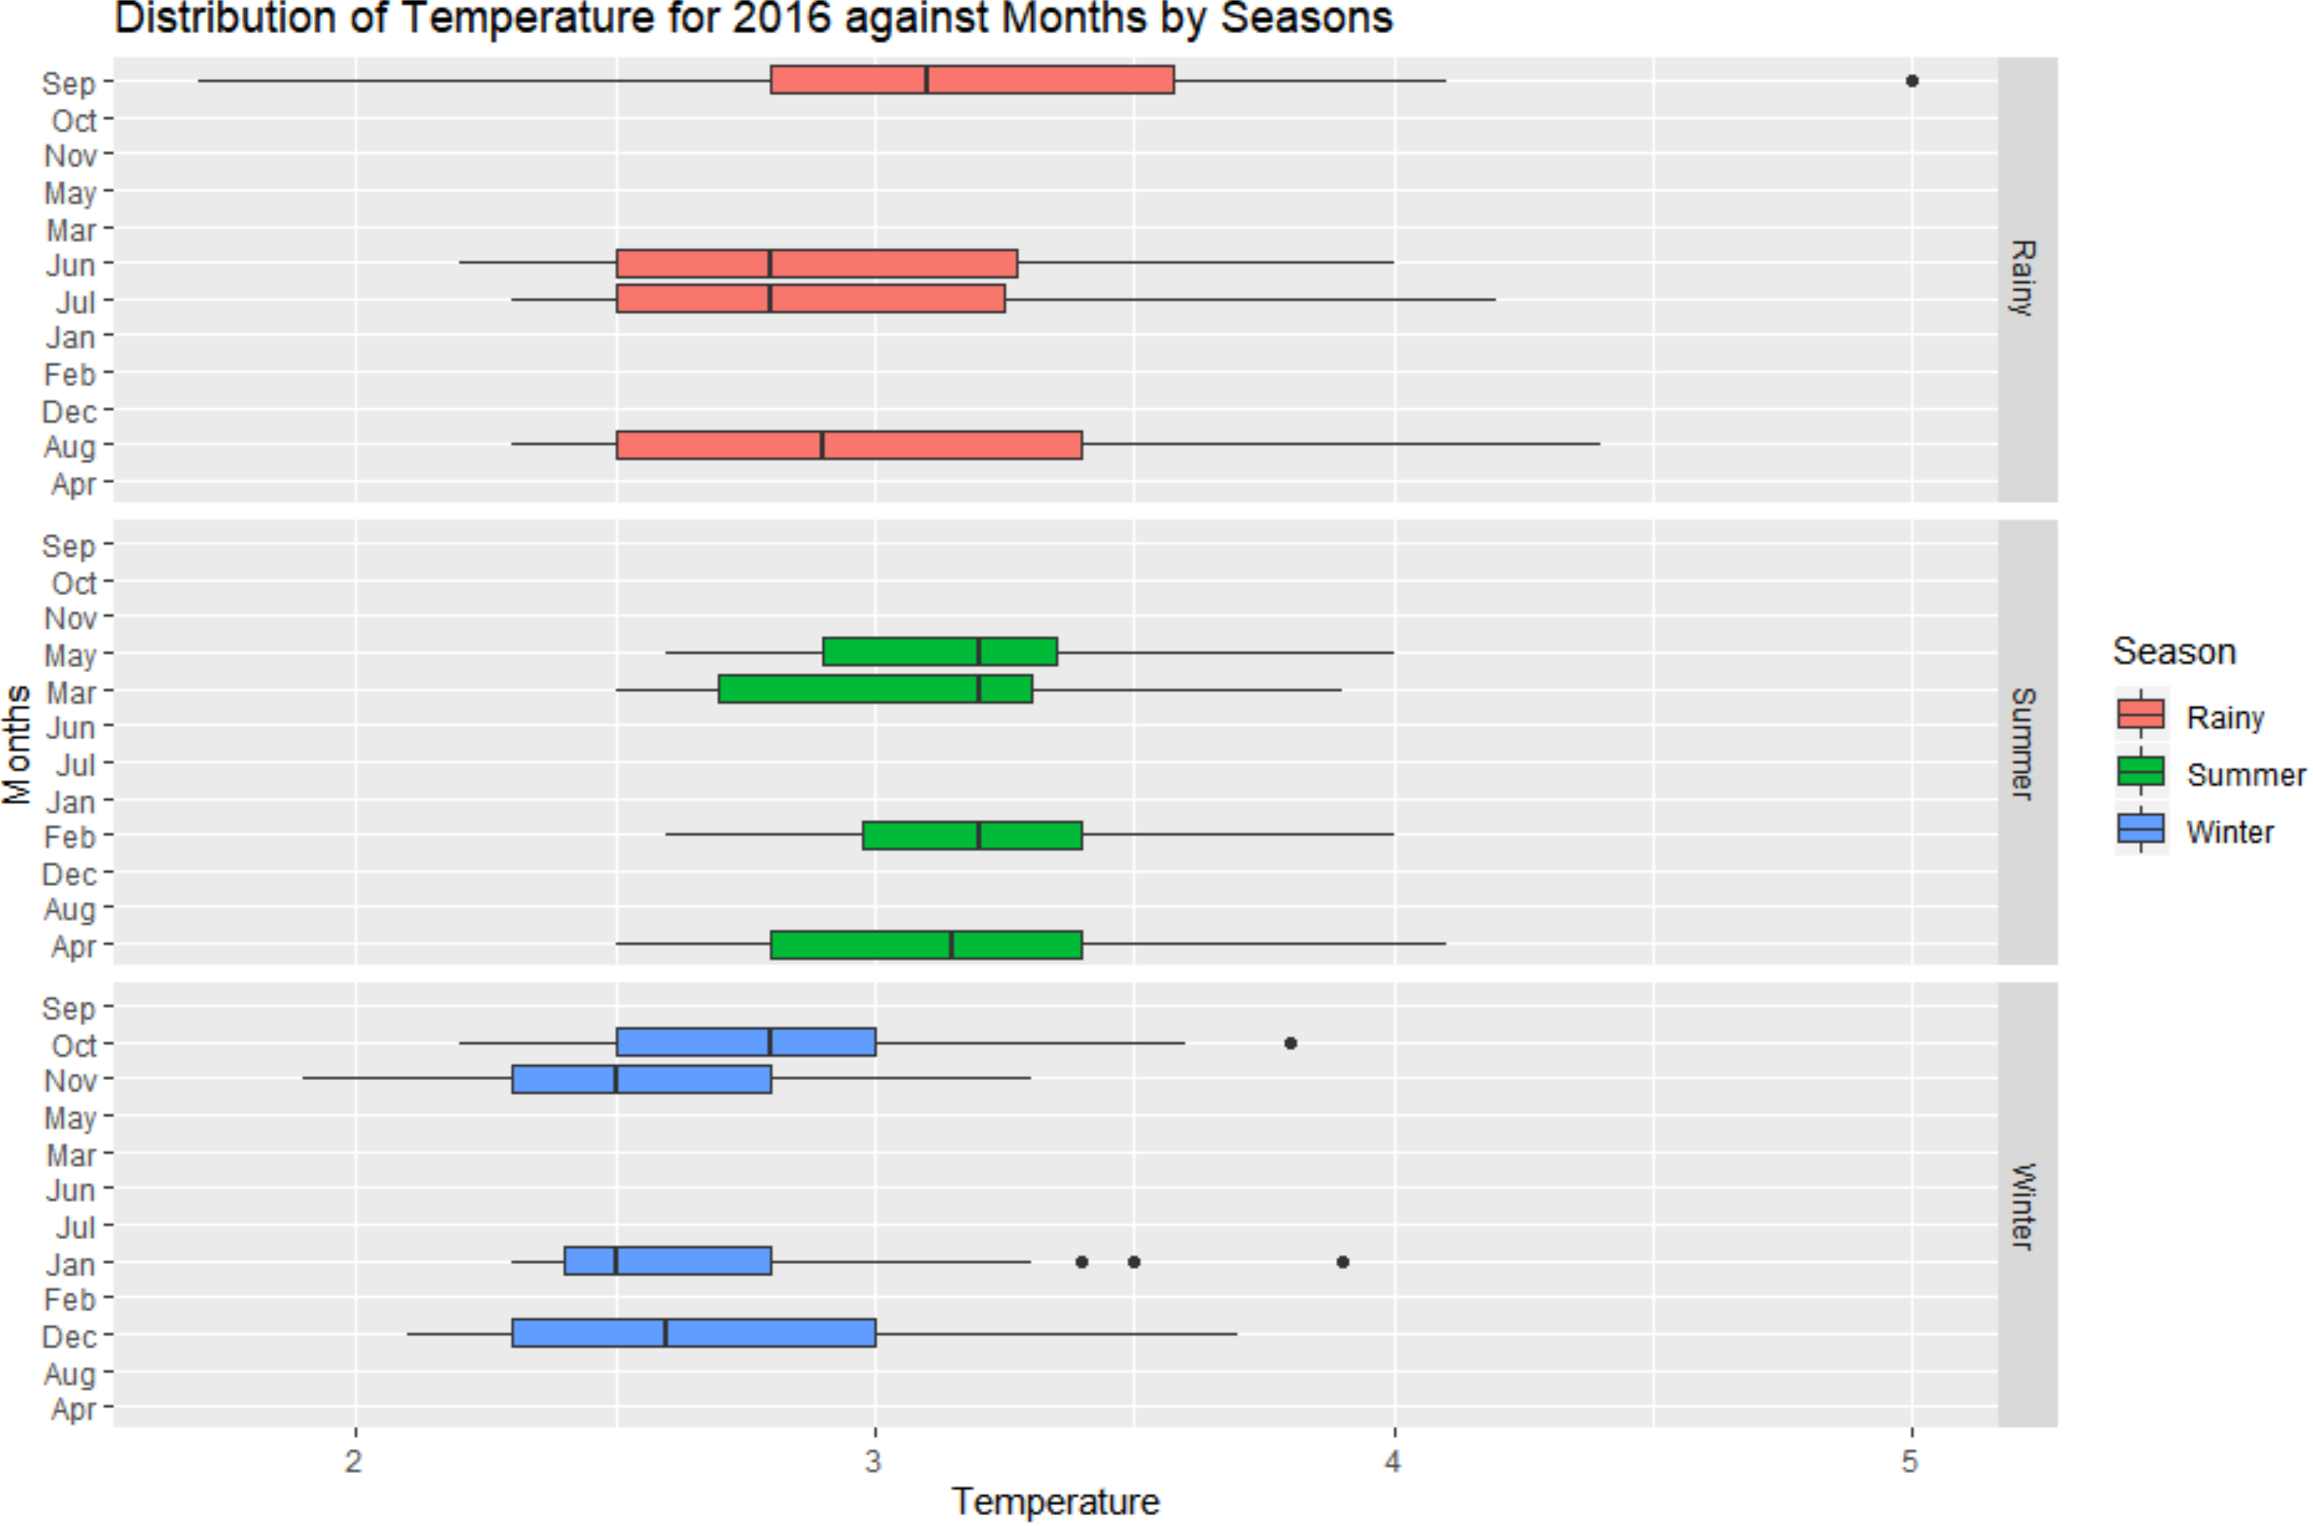

Observations: From the above plot, we deduct the important info that out of all the outliers that happened on Jan & Oct months, they belong to Winter Season. So we can attribute Winter season as the major contributor of outliers. Along the same line, we can also deduct that the remaining outlier that happened on September falls under Rainy Season. The Summer season data looks more consistent as there are no outliers there.

Please refer Appendix A for Source Code.

3.5 Missing Value Identification
We have checked for any missing values using anyNA() function and it turned out that there are no missing values in either of the data sets.

Please refer Appendix A for Source Code.

3.6 Outlier Identification

We can identify the outliers using the boxplot() function. The results are below

Dataset 1:
5, 5 ( 2 Outliers for Temperature variable)

Dataset 2:
4.6 ( 1 outlier for temperature variable)

Please refer Appendix A for Source Code.

3.7 Variable Transformation / Feature Creation
Our project doesn’t demand for any Variable Transformation/Feature Creation

4 Assignment Questions & Solutions

4.1 Problem 1 :

- Find mean cold storage temperature for Summer, Winter and Rainy Season
Answer:
Season Mean_Temp
<fct> <dbl>
1 Rainy 3.04
2 Summer 3.15
3 Winter 2.70

Explanation: We used the dplyr group_by function to group the observations by Season and then summarized the results by mean of temperature

- Find overall mean for the full year
Answer:
- 2.96274

Explanation: We used the mean() function to get the mean of full year

- Find Standard Deviation for the full year (6 marks)
Answer:
- 0.508589

Explanation: We used the sd() function to get the standard deviation of full year

- Assume Normal distribution, what is the probability of temperature having fallen below 2 C? (6 marks)
Answer:
- 0.02918146

Explanation: We used the pnorm() function with x=2 and added mean & sd to get the probability of temperature below 2 C

- Assume Normal distribution, what is the probability of temperature having gone above 4 C? (6 marks)
Answer:
- 0.02070077

Explanation: We used the pnorm() function with x=4 and added mean & sd to get the probability of temperature below 4 C. We then Subtracted 1- pnorm() value to get the temperature above 4 C

- What will be the penalty for the AMC Company? (7.5 marks)
Answer:
Total Probability of Temperature falling outside of 2-4 range is : 0.04988223

So Penalty = 10% of AMC fee

Explanation: We first calculated the total probability for which the temperature will be less than 2 OR greater than 4. These probabilities added up to 4.99% which is lower than 5%. So as per the details provided to us, the penalty would be 10% of the AMC fee.

Please refer Appendix A for Source Code.

4.1 Problem 2 :

- Which Hypothesis test shall be performed to check the if corrective action is needed at the cold storage plant? Justify your answer.

TAnswer: We will perform the Student’s one sample t-test hypotheis (T-test)for this sample to check if corrective action is required or not.

Justification: In this problem we are only given with a sample data of 35 days. Usually if the number of samples > 30, we can go with a Z test but provided that we have a known population Standard deviation. In our problem we have only the sample standard deviation and there is no data on population, So we go with Student’s t-Test which is ideal when the number of samples < 30. However in this scenario, we can proceed with the Stdents t-Test even though number of samples = 35 due to non availability of population data.

- State the Hypothesis, perform hypothesis test and determine p-value

Answer: The Hypothesis is stated as below :
Null Hypothesis : Mean temperature <= 3.9 and no need for any corrective action at the plant
Alternate Hypothesis: Mean temperature > 3.9 and corrective action is needed.
After selecting a confidence Interval of 90% (alpha = 0.1/conf.level=0.9), mu=3.9 and alternative=”greater” in R for t.test() function, we got the p Value as 0.004711.

- Give your inference
Answer: Since our p-Value (0.004) is much lower than alpha (0.1), we will reject the Null hypothesis with much confidence (99.6%) and it points to the fact that we need some corrective action at the plant, thus justifying the alternate hypothesis.

Please refer Appendix A for Source Code.

4 Conclusion

For the Cold Storage problem, we exported the data sets and analyzed the same before formulating the hypothesis. In each of the data sets there were 4 attributes provided namely - Season, Month, Date & Temperature. The only continuous varaibale in the list was “Temperature” and all other three were categorical variables. We did Univariate analysis for Temperature and then bivariate/multivariate analysis for Month-Temperature, Season-Temperature & Month-Season -Temperature combinations. Some observations that we made for 2016 data was that the temperature recorded were not very consistent for Winter season and in particular during the Jan month. However the greatest/lowest recordings were observed during Sep month of 2016.We also verified that there were no missing value in the data set and also found out the outliers in general and for specific combinations of Season-Temperature , Month-Temperature.

From 2016 sample, we found out the total probability of the temperature deviating out of 2-4 C range was about 4.99%. Thus we arrived at the penalty for AMC company- as 10% of maintenance case (because probability of temperature is not exceeding 5%).

And for 2018 data, we verified that all the observed values are from ‘Summer” season which might bring in some seasonality bias to our analysis. However we looked at the sample to determine the apt hypothesis and narrowed it to the Students T-test. After defining the hypothesis, we did the test and found out evidence with good confidence to reject the Null hypothesis and thus arriving at the conclusion that the mean temperature is exceeding 3.9 C and so we really need to do some corrective action at the Cold Storage plant as an immediate future measure.

5 Appendix A – Source Code

#=======================================================================
#
# Exploratory Data Analysis & Hypothesis Testing - Cold Stotage Datasets
#
#=======================================================================

#Installing packages & loading Libraries

install.packages("dplyr")
install.packages("ggplot2")

library(dplyr)
library(ggplot2)

# Setting the directory
getwd()
setwd("C:/2020/RProgramming/SMDM")

# Importing the data
Cold_Storage_2016 <- read.csv("Cold_Storage_Temp_Data.csv")
Cold_Storage_Mar2018 <- read.csv("Cold_Storage_Mar2018.csv")
View(Cold_Storage_2016)
View(Cold_Storage_Mar2018)

# Checking dimensions- number of rows & cols
dim(Cold_Storage_2016)
dim(Cold_Storage_Mar2018)

# Retreiving Column names
names(Cold_Storage_2016)
names(Cold_Storage_Mar2018)

# Checking the Structure of variables
str(Cold_Storage_2016)
str(Cold_Storage_Mar2018)

# Checking the 5-point Summary
summary(Cold_Storage_2016)
summary(Cold_Storage_Mar2018)

# Checking first 6 records from the dataset
head(Cold_Storage_2016)
head(Cold_Storage_Mar2018)

# Checking last 6 records from the dataset
tail(Cold_Storage_2016)
tail(Cold_Storage_Mar2018)

## Univariate Analysis of the Continous Variable
##ggplot()-histogram for Univariate analysis

#Dataset -1
Cold_Storage_2016 %>%
ggplot(aes(Temperature)) +
geom_histogram(binwidth = 0.25, color = "black",fill = "aquamarine") +
labs(title = "Distribution of Temperature for 2016",
x = "Temperature",
y = "Number of Observations") +
scale_x_continuous(breaks = seq(1,6,1))

#Dataset -2
Cold_Storage_Mar2018 %>%
ggplot(aes(Temperature)) +
geom_histogram(binwidth = 0.25, color = "black",fill = "pink") +
labs(title = "Distribution of Temperature for Mar-2018",
x = "Temperature",
y = "Number of Observations") +
scale_x_continuous(breaks = seq(3,6,0.5))

# Univariate Analysis of the Categorical Variable

# Tabular format for Categorical variable
table(Cold_Storage_2016$Season)
table(Cold_Storage_Mar2018$Season)

## Univariate Analysis for Categorical variable (Bar Plot)

# Dataset-1
Cold_Storage_2016 %>%
ggplot() +
geom_bar(aes(Season), color = "black",fill = "grey") +
coord_flip() +
labs(title = "Number of temperature Measurements per Season-2016",
x = "Seasons",
y = "Temperature Measurements")

# Dataset-2
Cold_Storage_Mar2018 %>%
ggplot() +
geom_bar(aes(Season), color = "black",fill = "grey") +
coord_flip() +
labs(title = "Number of temperature Measurements per Season-2018",
x = "Seasons",
y = "Temperature Measurements")

# Bivariate Analysis of a Numerical & Categorical Variable
## Boxplots by Seasons

# Dataset-1
Cold_Storage_2016 %>%
ggplot(aes(Season, Temperature)) +
geom_boxplot(aes(fill=Season)) +
labs(title = "Distribution of Temperature for 2016 against Seasons",
x = "Seasons",
y = "Temperature")

# Dataset-2
Cold_Storage_Mar2018 %>%
ggplot(aes(Season, Temperature)) +
geom_boxplot(aes(fill=Season)) +
labs(title = "Distribution of Temperature for Mar2018 against Seasons",
x = "Seasons",
y = "Temperature")

## Boxplots by Months

# Dataset-1
Cold_Storage_2016 %>%
ggplot(aes(Month, Temperature)) +
geom_boxplot(aes(fill=Month)) +
labs(title = "Distribution of Temperature for 2016 against Months",
x = "Months",
y = "Temperature")

# Dataset-2
Cold_Storage_Mar2018 %>%
ggplot(aes(Month, Temperature)) +
geom_boxplot(aes(fill=Month)) +
labs(title = "Distribution of Temperature for Mar2018 against Months",
x = "Months",
y = "Temperature")

## Multivariate Plots

#Dataset-1
Cold_Storage_2016 %>%
ggplot(aes(Month, Temperature)) +
geom_boxplot(aes(fill=Season)) +
labs(title = "Distribution of Temperature for 2016 against Months by Seasons",
x = "Months",
y = "Temperature") +
facet_grid(Season~.) +
coord_flip()

#Data set-2
Cold_Storage_Mar2018 %>%
ggplot(aes(Month, Temperature)) +
geom_boxplot(aes(fill=Season)) +
labs(title = "Distribution of Temperature for 2016 against Months by Seasons",
x = "Months",
y = "Temperature") +
facet_grid(Season~.) +
coord_flip()

#Missing Value Identification
anyNA(Cold_Storage_2016)
anyNA(Cold_Storage_Mar2018)
#colSums(is.na(Cold_Storage_2016))

## Outlier Identification

boxplot(Cold_Storage_2016[,4])$out
boxplot(Cold_Storage_Mar2018[,4])$out

###########################PART-1########################################
# Q1. Find mean cold storage temperature for Summer, Winter and Rainy Season
#aggregate (Cold_Storage$Temperature,by=list(Cold_Storage$Season), FUN=mean)

#tapply(X=Temperature, INDEX= Season, FUN=mean)
#by(Cold_Storage$Temperature, INDICES=Season, FUN=mean) #Data by list
#aggregate(Temperature~Season, data=Cold_Storage, FUN = mean)

Cold_Storage_2016 %>% select(Season,Temperature) %>%
group_by(Season) %>%
summarise(Mean_Temp = mean(Temperature))

# Q2. Find overall mean for the full year
mean(Cold_Storage_2016$Temperature)

# Q3. Find Standard Deviation for the full year
sd(Cold_Storage_2016$Temperature)

# Q4. Assume Normal distribution, what is the probability of temperature having fallen below 2 C?
Temp_Under_2_Prob <- pnorm(2,mean(Cold_Storage_2016$Temperature), sd(Cold_Storage_2016$Temperature))

Temp_Under_2_Prob

# Q5. Assume Normal distribution, what is the probability of temperature having gone above 4 C?
Temp_Over_4_Prob <- 1 - pnorm(4,mean(Cold_Storage_2016$Temperature), sd(Cold_Storage_2016$Temperature))

Temp_Over_4_Prob

# Q6. What will be the penalty for the AMC Company?
Temp_Outside_Tot_Prob <- Temp_Under_2_Prob + Temp_Over_4_Prob
Temp_Outside_Tot_Prob

# A6: AMC Penalty = 10% of Annual Maintenance because total probability of the
#temperature exceeding 2-4 limit is only 4.99% which is lower than 5%

############################PART-2########################################

# Q1. Which Hypothesis test shall be performed to check the if corrective action is needed at the cold storage plant? Justify your answer.
# A1: Students t-Test

# Q2. State the Hypothesis, perform hypothesis test and determine p-value
# A2:
H0: Temp <= 3.9
HA: Temp > 3.9
Alpha = 0.1

# Q3. Give your inference
# Calculating t-Test below:

t.test(Cold_Storage_Mar2018$Temperature, y=NULL, mu=3.9,conf.level=0.9,alternative = "greater")

#t Statistic value = 2.7524
#P Value = 0.004711 < 0.1 ==> Null Hypothesis is Rejected.
#Inference: Since p value is leass than 0.1 (alpha), a corrective action is needed at the Cold Storage.

#################### THE END ###############################

###

